Batch: B2 Roll No.: 16010121200

Experiment No. 7

Grade: AA / AB / BB / BC / CC / CD /DD

Signature of the Staff In-charge with date

Title: Fuzzification methods and operations on fuzzy set
____________________________________________________________________________________
Aim: To implement fuzzification methods and perform operations on fuzzy sets
____________________________________________________________________________________
Expected Outcome of Experiment:

CO4: Apply basics of Fuzzy logic and neural networks ____________________________________________________________________________________
Books/ Journals/ Websites referred:
____________________________________________________________________________________
Pre Lab/ Prior Concepts:
Fuzzy logic:
Fuzzy logic is a mathematical approach that allows for more flexible reasoning, resembling human logic by representing data with degrees of truth rather than binary true/false values. It is particularly useful in situations where information is imprecise or uncertain. Fuzzy logic uses linguistic variables, fuzzy sets, and rules to make decisions, and is commonly used to handle complex, real-world scenarios where crisp, binary logic falls short.
Definition of membership function (and fuzzy set):
A membership function is a fundamental concept in fuzzy logic, defining how elements belong to a fuzzy set by assigning each element a degree of membership within the set, typically on a scale from 0 to 1.
A fuzzy set is a collection of elements with imprecise or gradual boundaries, allowing for the representation of uncertainty or vagueness in data. Membership functions determine the extent to which each element can be considered part of the fuzzy set, enabling a more flexible and nuanced representation of data in fuzzy logic applications.

Fuzzy set operations:
Fuzzy set operations are as follows:
- Equality
- Complement
- Intersection
- Union
- Algebraic product
- Multiplication of fuzzy set with crisp number
- Power of fuzzy set
- Algebraic sum
- Algebraic difference
- Bounded sum
- Bounded difference
- Cartesian product
- Composition

Fuzzy inference system:
A fuzzy inference system is a computational framework used in fuzzy logic that processes fuzzy input data through a set of predefined fuzzy rules and membership functions to produce a fuzzy output. It involves interpreting imprecise or uncertain information and making decisions or controlling systems based on this input. The system combines the fuzzy rules and input values to generate a fuzzy output, which may then be defuzzified to obtain a specific, actionable result. Fuzzy inference systems are valuable in situations where traditional crisp logic falls short, enabling more robust decision-making in complex, real-world scenarios.

___________________________________________________________________________________

Implementation Details:

- Implement the following membership functions and visualize the same.

import matplotlib.pyplot as plt
import numpy as np
from tabulate import tabulate

  - Triangular
# TRIANGULAR membership function
def triangular_member(x, a, b, c):
"""Triangular membership function"""
if x <= a:
return 0.0
elif a < x <= b:
return (x - a) / (b - a)
elif b < x <= c:
return (c - x) / (c - b)
else:
return 0.0

# Define parameters
a_values = [0, 5, 10, 15]
b_values = [4, 11, 18, 22]
c_values = [10, 15, 25, 30]
parameters = parameters = list(zip(a_values, b_values, c_values))

# Calculate membership values for different ranges
table = [] # To store results
input_values = [7, 12, 19, 23] # Input values

for x in input_values:
row = [f"x = {x}"]
for a, b, c in parameters:
result = triangular_member(x, a, b, c)
row.append(round(result, 3))
table.append(row)

headers = ["Input Value"] + [f"Range [{a}, {c}]" for a, b, c in parameters]
print("\nTriangular Membership")
print(tabulate(table, headers, tablefmt="grid"))

# Create plots for each triangular membership function
x_values = np.linspace(0, 30, 500)
for a, b, c in zip(a_values, b_values, c_values):
y_values = [triangular_member(x, a, b, c) for x in x_values]
plt.plot(x_values, y_values, label=f'({a}, {b}, {c})')

plt.xlabel('X-axis')
plt.ylabel('Degree of Belonging')
plt.title('Triangular Membership Functions')
plt.legend()
plt.show()

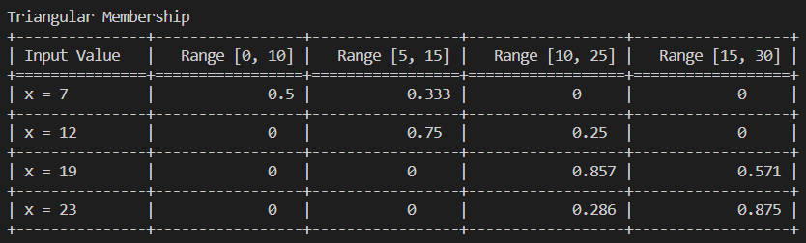
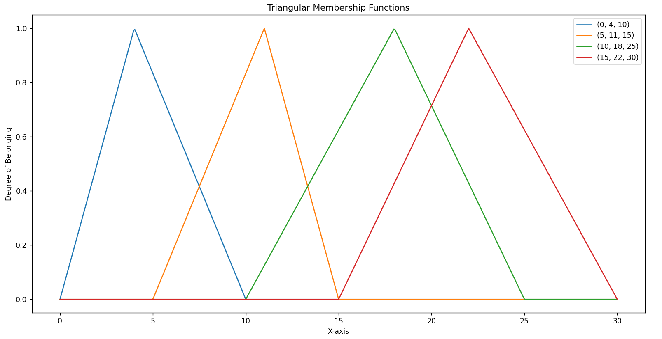

  - Trapezoidal
# TRAPEZOIDAL membership function
def trapezoidal_member(x, a, b, c, d):
"""Trapezoidal membership function"""
if x <= a:
return 0.0
elif a < x < b:
return (x - a) / (b - a)
elif b <= x <= c:
return 1.0
elif c < x < d:
return (d - x) / (d - c)
else:
return 0.0

# Define parameters
a_values = [0, 5, 10, 15]
b_values = [3, 8, 15, 21]
c_values = [7, 11, 20, 25]
d_values = [10, 15, 25, 30]
parameters = list(zip(a_values, b_values, c_values, d_values))

# Calculate membership values for different ranges
table = [] # To store results
input_values = [6, 12, 14, 23] # Input values

for x in input_values:
row = [f"x = {x}"]
for a, b, c, d in parameters:
result = trapezoidal_member(x, a, b, c, d)
row.append(round(result, 3))
table.append(row)

headers = ["Input Value"] + [f"Range [{a}, {d}]" for a, b, c, d in parameters]
print("\nTrapezoidal Membership")
print(tabulate(table, headers, tablefmt="grid"))

# Create plots for each trapezoidal membership function
x_values = np.linspace(0, 30, 500)
for a, b, c, d in zip(a_values, b_values, c_values, d_values):
y_values = [trapezoidal_member(x, a, b, c, d) for x in x_values]
plt.plot(x_values, y_values, label=f'({a}, {b}, {c}, {d})')

plt.xlabel('X-axis')
plt.ylabel('Degree of Belonging')
plt.title('Trapezoidal Membership Functions')
plt.legend()
plt.show()

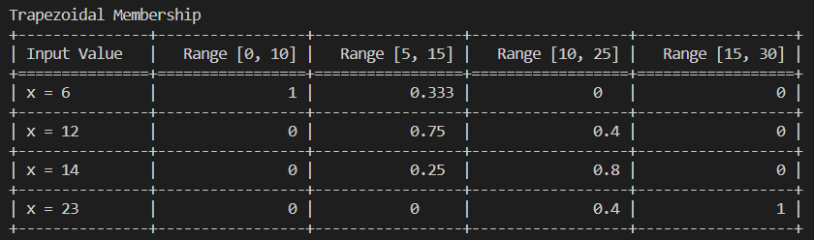
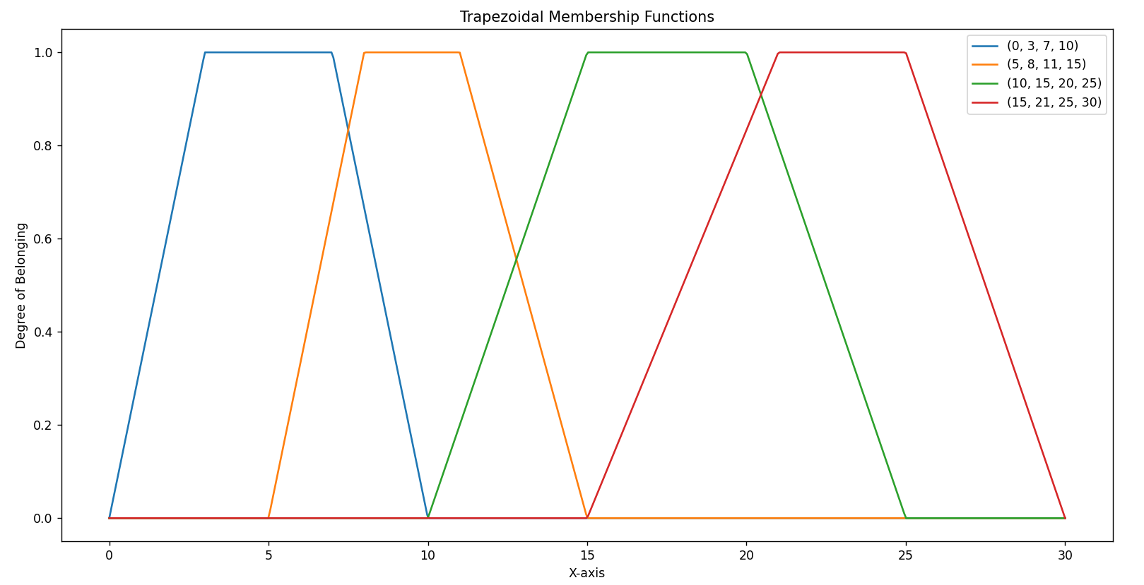

  - Gaussian
# GAUSSIAN membership function
def gaussian_member(x, center, sd):
"""Gaussian membership function"""
return np.exp(-0.5 * ((x - center) / sd) ** 2)

# Define parameters
center = 7
std_dev = 2
parameters = [(center, std_dev)]

# Create plot for gaussian membership function
x_values = np.linspace(0, 15, 500)
for center, sd in parameters:
y_values = [gaussian_member(x, center, sd) for x in x_values]
plt.plot(x_values, y_values, label=f'Center={center}, SD={sd}')

plt.xlabel('X-axis')
plt.ylabel('Degree of Belonging')
plt.title('Gaussian Membership Functions')
plt.legend()
plt.show()
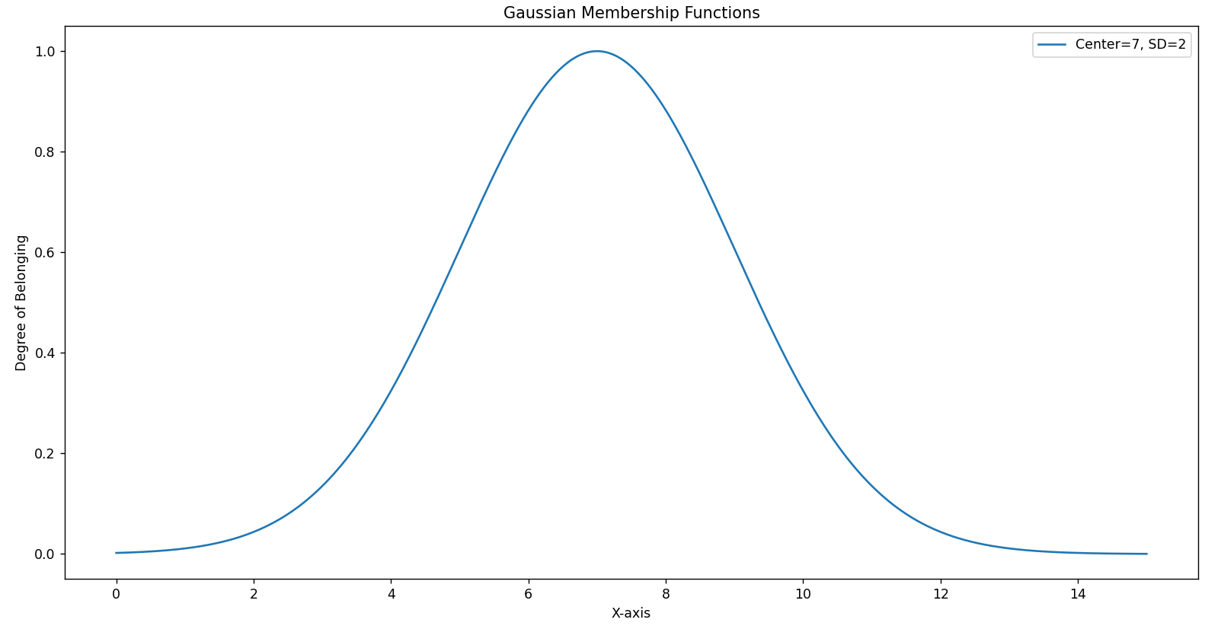

  - Generalized
# GENERALIZED membership function
def generalized_member(x, sd, mean, center):
"""Generalized membership function"""
return 1 / (1 + np.abs((x - center) / sd) ** (2 * mean))

# Define parameters
std_dev = 2
mean = 3
center = 7
parameters = [(std_dev, mean, center)]

# Create plot for generalized membership function
x_values = np.linspace(0, 15, 500)
for sd, mean, center in parameters:
y_values = [generalized_member(x, sd, mean, center) for x in x_values]
plt.plot(x_values, y_values, label=f'SD={sd}, Mean={mean}, Center={center}')

plt.xlabel('X-axis')
plt.ylabel('Degree of Belonging')
plt.title('Generalized Membership Functions')
plt.legend()
plt.show()
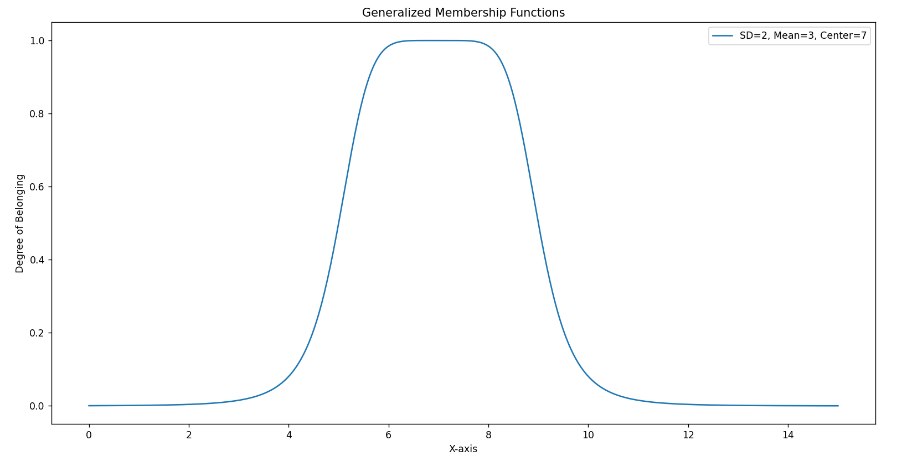

  - Sigmoid
# SIGMOIDAL membership function
def sigmoidal_member(x, a, b):
"""Sigmoidal membership function"""
return 1 / (1 + np.exp(-a * (x - b)))

# Define parameters
a = 1
b = 0
parameters = [(a, b)]

# Create plot for generalized membership function
x_values = np.linspace(-10, 10, 500)
for a, b in parameters:
y_values = [sigmoidal_member(x, a, b) for x in x_values]
plt.plot(x_values, y_values, label=f'a={a}, b={b}')

plt.xlabel('X-axis')
plt.ylabel('Degree of Belonging')
plt.title('Sigmoidal Membership Functions')
plt.legend()
plt.show()
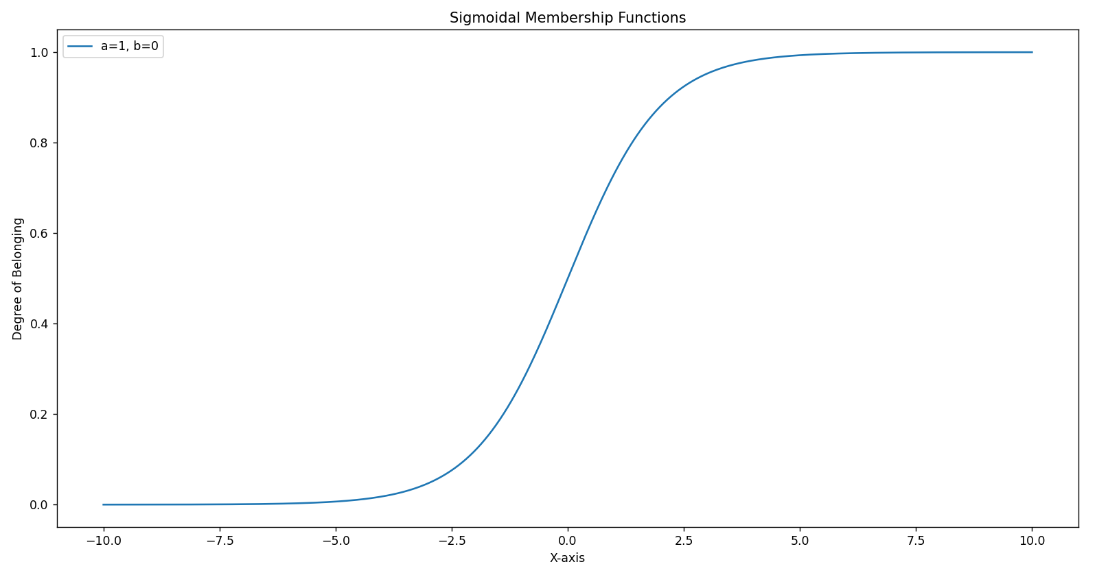

- Implement the fuzzy operations - Union, intersection, complement and visualize the same.
import numpy as np
import matplotlib.pyplot as plt

def fuzzy_complement(setA):
complement = []
for value in setA:
complement.append(round(1-value, 3))
return complement

def fuzzy_intersection(setA, setB):
intersection = []
for value in list(zip(setA, setB)):
intersection.append(min(value))
return intersection

def fuzzy_union(setA, setB):
union = []
for value in list(zip(setA, setB)):
union.append(max(value))
return union

def fuzzy_product(setA, setB):
product = []
for value1, value2 in list(zip(setA, setB)):
product.append(round(value1 * value2, 3))
return product

def fuzzy_crisp_multiplication(setA, crisp):
multiplication = []
for value in setA:
multiplication.append(round(value * crisp,3))
return multiplication

set_A = (0.7, 0.3, 0.9, 0.1)
set_B = (0.2, 0.5, 0.7, 0.4)
set_C = (0.1, 0.2, 0.3, 0.4)
set_D = (0.5, 0.7, 0.8, 0.9)

print("Set 1 =", set_A, sep = "\t")
print("set 2 =", set_B, sep = "\t")
print("Complement =", fuzzy_complement(set_A), sep = "\t")
print("Intersection =", fuzzy_intersection(set_A, set_B), sep = "\t")
print("Union =", fuzzy_union(set_A, set_B), sep = "\t\t")
print()
print("Set 3 =", set_C, sep = "\t")
print("set 4 =", set_D, sep = "\t")
print("Product =", fuzzy_product(set_C, set_D), sep = "\t")
print("Multiplication=", fuzzy_crisp_multiplication(set_C, 0.2))
Output:
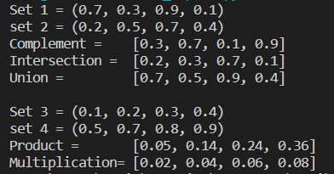

Visualizations:
Union:
# Plot the membership functions and their union
x_values = np.linspace(0, 10, 500)

# Function 1 (Triangular)
a, b, c = 3, 4, 5
y_values_triangular = [triangular_member(x, a, b, c) for x in x_values]
plt.plot(x_values, y_values_triangular, 'g', label=f'T({a}, {b}, {c})')

# Function 2 (Trapezoidal)
a, b, c, d = 4, 5, 8, 9
y_values_trapezoidal = [trapezoidal_member(x, a, b, c, d) for x in x_values]
plt.plot(x_values, y_values_trapezoidal, 'r', label=f'Tr({a}, {b}, {c}, {d})')

# Union
union_values = fuzzy_union(y_values_triangular, y_values_trapezoidal)
plt.plot(x_values, union_values, 'blue', label='Union')
plt.title('Union (OR) Operator')
plt.xlabel('X-axis')
plt.ylabel('Membership Value')
plt.legend()
plt.show()

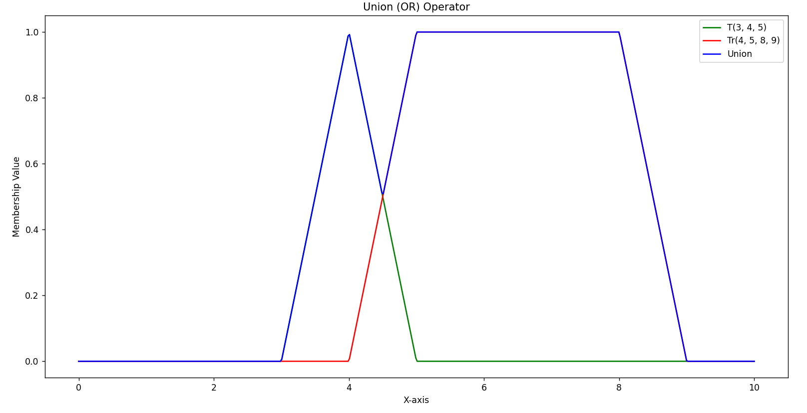

Intersection:
# Plot the membership functions and their intersection
x_values = np.linspace(0, 10, 500)

# Function 1 (Triangular)
a, b, c = 3, 4, 5
y_values_triangular = [triangular_member(x, a, b, c) for x in x_values]
plt.plot(x_values, y_values_triangular, 'g', label=f'T({a}, {b}, {c})')

# Function 2 (Trapezoidal)
a, b, c, d = 4, 5, 8, 9
y_values_trapezoidal = [trapezoidal_member(x, a, b, c, d) for x in x_values]
plt.plot(x_values, y_values_trapezoidal, 'r', label=f'Tr({a}, {b}, {c}, {d})')

# Intersection
intersection_values = fuzzy_intersection(y_values_triangular, y_values_trapezoidal)
plt.plot(x_values, intersection_values, 'yellow', label='Intersection')
plt.title('Intersection (AND) Operator')
plt.xlabel('X-axis')
plt.ylabel('Membership Value')
plt.legend()
plt.show()

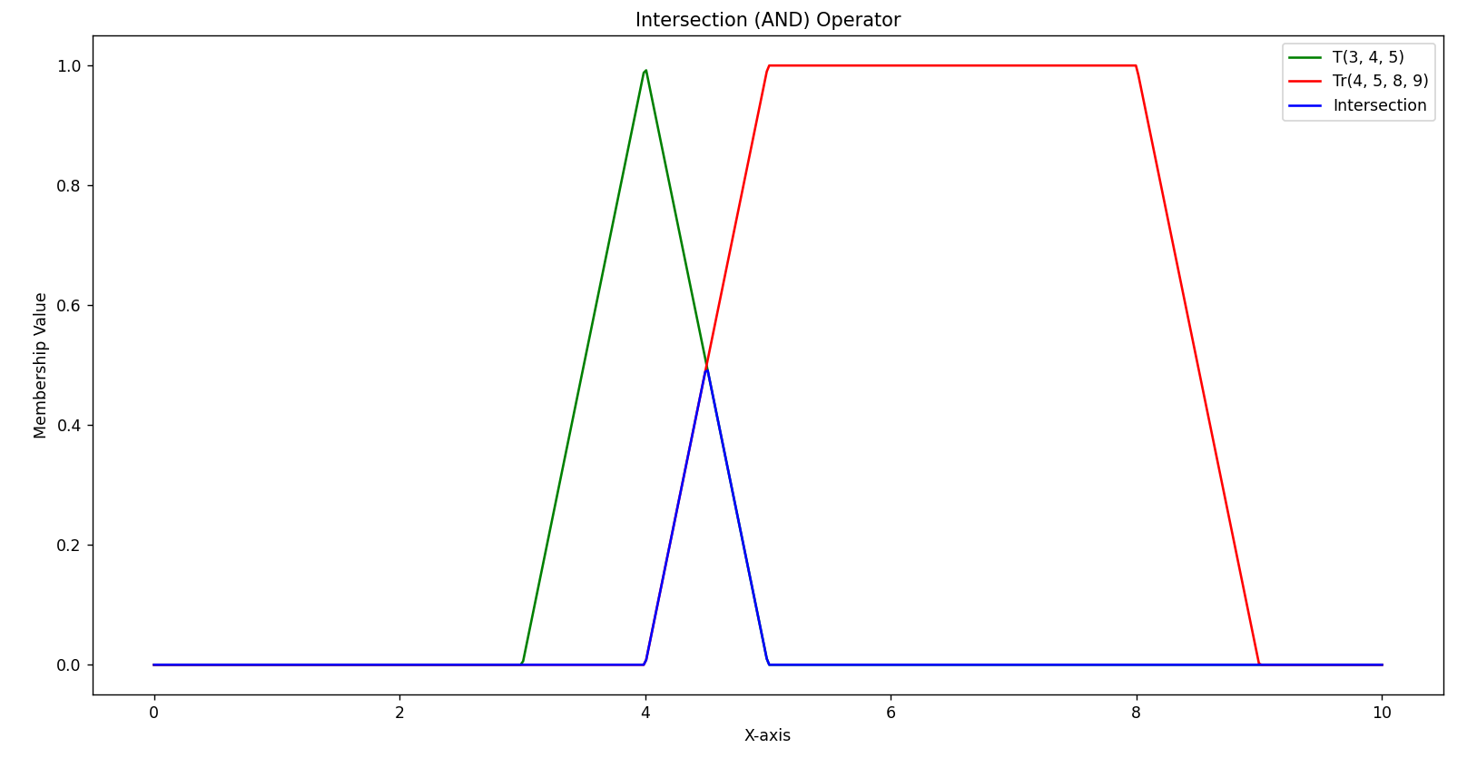
Complement:
# Plot the membership functions and their intersection
x_values = np.linspace(0, 10, 500)

# Function 1 (Triangular)
a, b, c = 3, 4, 5
y_values_triangular = [triangular_member(x, a, b, c) for x in x_values]
plt.plot(x_values, y_values_triangular, 'g', label=f'T({a}, {b}, {c})')

# Function 2 (Trapezoidal)
a, b, c, d = 4, 5, 8, 9
y_values_trapezoidal = [trapezoidal_member(x, a, b, c, d) for x in x_values]
plt.plot(x_values, y_values_trapezoidal, 'r', label=f'Tr({a}, {b}, {c}, {d})')

# Complement
complement_values = fuzzy_complement(y_values_trapezoidal)
plt.plot(x_values, complement_values, 'black', label='Complement')
plt.title('Complement (NOT) Operator')
plt.xlabel('X-axis')
plt.ylabel('Membership Value')
plt.legend()
plt.show()
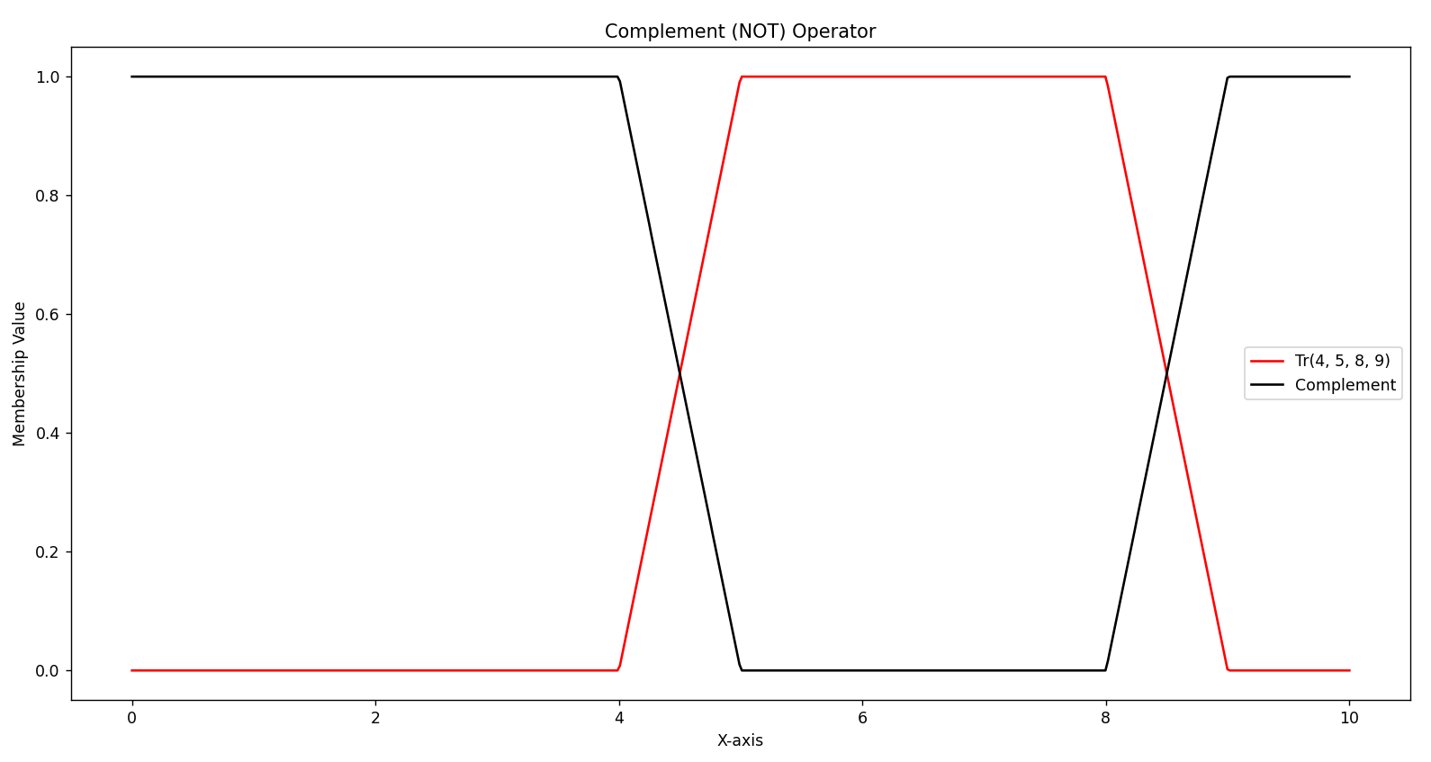

Post Lab Descriptive Questions:

- Implement the fuzzy membership functions to define the fuzzy set for the following course evaluation crisp set.
(Hint: Descriptors for fuzzy set can be bad, poor, average, good, very good, excellent)
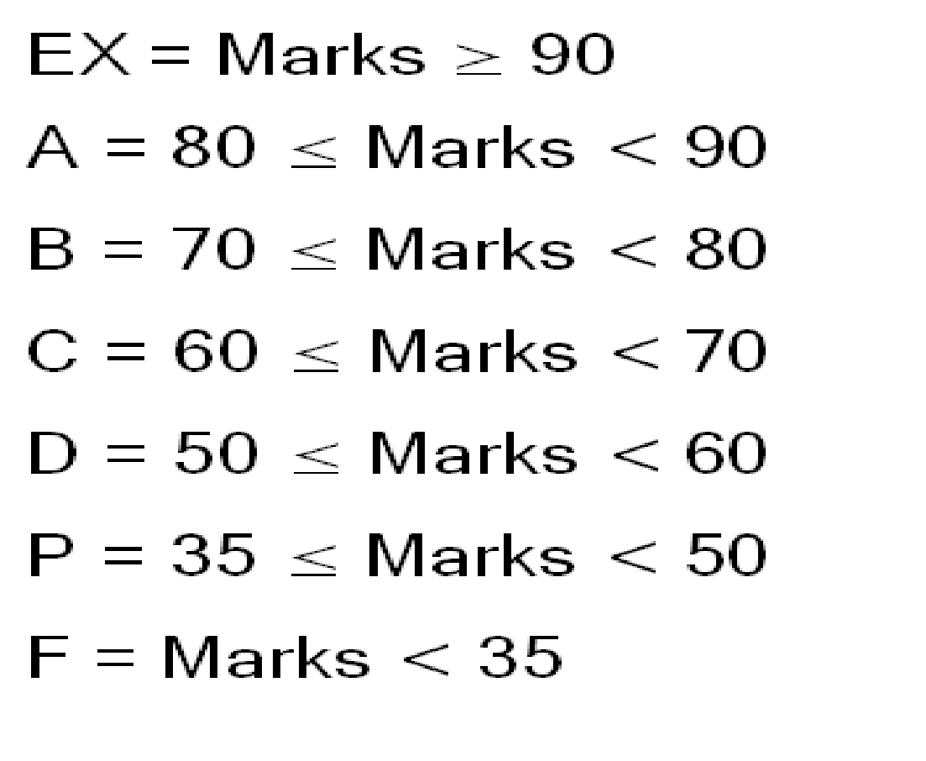
import numpy as np
import matplotlib.pyplot as plt

# Trapezoidal membership functions for each term
# TRAPEZOIDAL membership function
def trapezoidal_member(x, a, b, c, d):
"""Trapezoidal membership function"""
if x <= a:
return 0.0
elif a < x < b:
return (x - a) / (b - a)
elif b <= x <= c:
return 1.0
elif c < x < d:
return (d - x) / (d - c)
else:
return 0.0

# Define parameters
a_values = [0, 30, 45, 55, 65, 75, 85]
b_values = [0, 36, 48, 60, 72, 80, 92]
c_values = [30, 45, 57, 69, 78, 90, 100]
d_values = [40, 55, 65, 75, 85, 95, 100]
labels = ['Very bad', 'Bad', 'Poor', 'Average', 'Good', 'Very good', 'Excellent']
parameters = list(zip(a_values, b_values, c_values, d_values))

# Create plots for each trapezoidal membership function
x_values = np.linspace(0, 100, 500)
for a, b, c, d, label_ in zip(a_values, b_values, c_values, d_values, labels):
y_values = [trapezoidal_member(x, a, b, c, d) for x in x_values]
plt.plot(x_values, y_values, label=label_)

plt.xlabel('X-axis')
plt.ylabel('Degree of Belonging')
plt.title('Fuzzy Course Evaluation Set')
plt.legend()
plt.show()

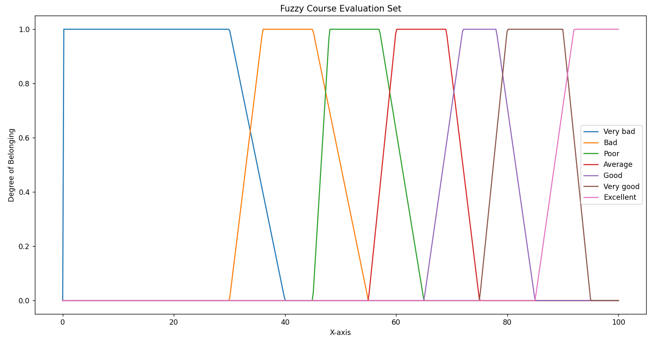

Date: 25/10/2023 Signature of faculty in-charge

